|  |
| --- |
| User Guide Saferpay Module  for PrestaShop 1.6 and 1.7  Version 1.04  04.02.2020 |
|  |

# Table of contents

Table of contents 2

About document 3

Description 4

Installation guide 5

PrestaShop way 5

FTP way 5

How to find the module 6

Settings tab 7

Test mode 7

Live/Test 7

Setting 10

Styling 11

Payments tab 12

Logs 13

Order management 14

Orders 14

Capture payment 15

Cancel the order 15

Refund payment 16

E-shop customer experience 17

Checkout 17

Credit card management 19

Support Contacts 20

# About document

|  |  |  |  |
| --- | --- | --- | --- |
| Document version | Prepared by | What was changed | Date |
| V1.00 | Simonas Jusas, UAB Invertus | Prepared initial document version | 2020-01-13 |
| V1.01 | Simonas Jusas, UAB Invertus | Added instructions how to find Terminal ID and API key in Saferpay management interface.  Include improvements done by Torben | 2020-01-21 |
| V1.02 | Erich Zeiler-Rausch, SIX Payment Services | Adaptation | 2020-01-27 |
| V1.03 | Simonas Jusas, UAB Invertus | Added chapters „How to find the module“ and „Order management“ | 2020-01-30 |
| V.1.04 | Erich Zeiler-Rausch, SIX Payment Services | Module renamed to saferpayofficial.zip | 2020-02-18 |

# Description

Saferpay - Easy, flexible, secure - The comprehensive e-payment solution from SIX Payment Services for easier and more secure payment in your online shop.

SIX Payment Services has been part of Worldline since the end of 2018, making it Europe's largest technology partner for banks and merchants. The tailor-made solutions from SIX Payment Services include a broad portfolio of payment terminals and the acceptance and processing of national and international payments with credit, debit and prepaid cards as well as the smartphone.

Worldline is European market leader in payment technology. More than 11,000 payment experts ensure future-oriented innovations and services in over 30 countries. With 45 years of experience, Worldline is an innovative pan-European company that covers the entire value chain of cashless payment transactions with its highly secure payment and transaction services.

Use of the Saferpay PrestaShop requires the following:

A corresponding license for the Saferpay module.

The existence of a valid identification with a username and password for the Saferpay Backoffice.

* + Respective API credentials for the Saferpay Live- and/or Test environment

Availability of at least one active Saferpay terminal via which payment can be carried out and the associated

Availability of Saferpay terminal number (Terminal ID parameter) and Saferpay customer number (CustomerId parameter).

Availability of valid acceptance agreement for credit cards or other payment methods.

# Installation guide

## PrestaShop way

* Log into Backoffice.
* Navigate to Modules -> Modules manager menu
* Click on Upload a module button, dialog box will appear



* Drag & drop saferpayofficial.zip file in to Upload a module dialog.
* You will receive **Module installed!** success message:

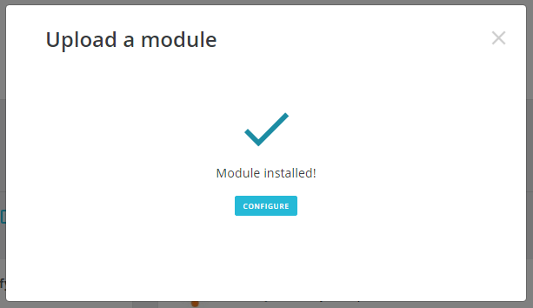

## FTP way

* Download saferpayofficial.zip file to your computer
* Extract it
* Upload Saferpay folder into PrestaShop modules directory
* Log into Backoffice
* Navigate to Modules -> Modules Catalog menu
* Type module name in the search.
* Hit the Install button to finish installation.

# How to find the module

After installation you will be able to go to configure straight from pop-up, however if you want to come back later there will not be pop-up.

To find Saferpay module go to Modules -> Module manager

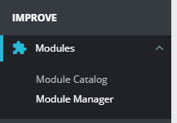

Type “Saferpay” in the search field at the top of Module manager page

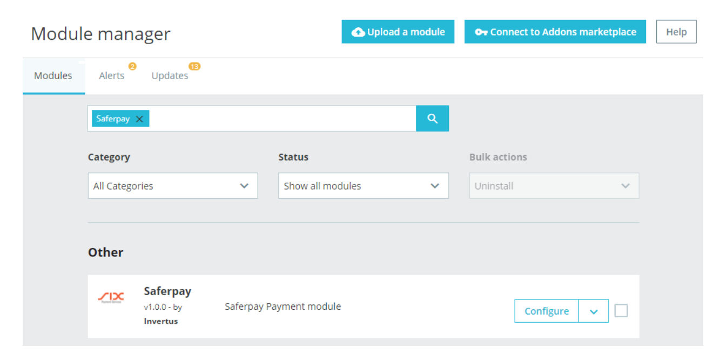

Click “Configure” to access module settings

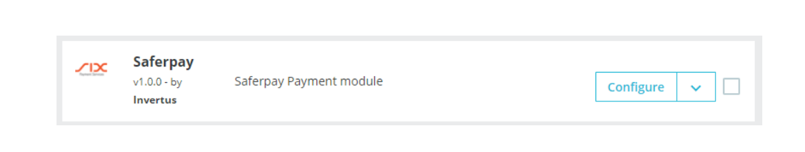

# Settings tab

Settings page is divided into five separate blocks. Lets’ discuss each block individually.

## Test mode

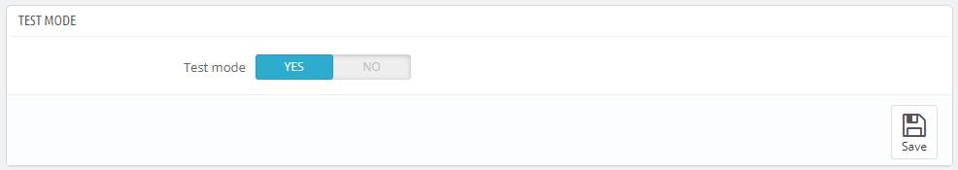

Test mode block consists only of one button. This button will allow merchant quickly switch between live and testing environment if the need occurs. By default, test mode is set to YES, so don’t forget to set it OFF when launching the shop.

## Live/Test

Live and test blocks are identical.

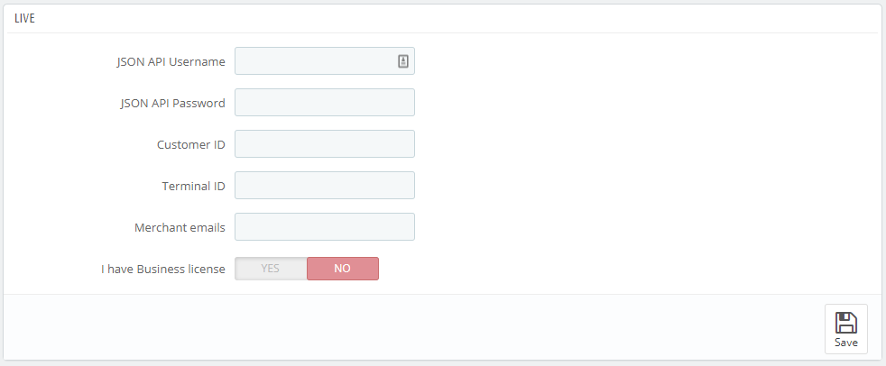

Live block has information regarding live environment. Test block has information regarding test environment. To get access information for live environment you have to [request an offer here](https://www.six-payment-services.com/en/site/e-commerce/solutions/paymentsolution.html). To get access information to test account please follow this [link](https://www.six-payment-services.com/en/site/e-commerce-developer/testaccount.html).

To get JSON API username and password you have to login to Saferpay management interface and go to Settings -> JSON API basic authentication or follow this link <https://test.saferpay.com/BO/Settings/JsonApiLogin> :

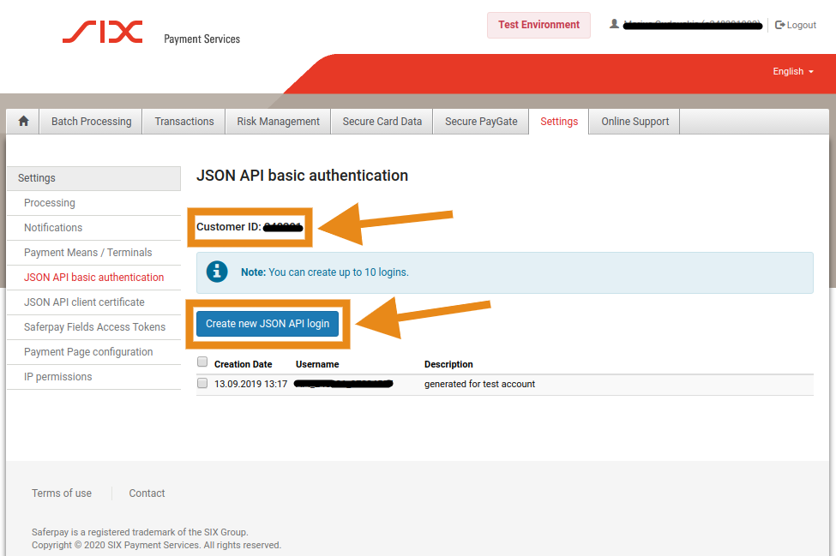

Click “Create new Json API login” to generate login information for API

You can also see Customer ID in the same page.

To get terminal ID, you need to go to Settings -> Payment means / Terminals or follow this link <https://test.saferpay.com/BO/Settings/Terminal> :

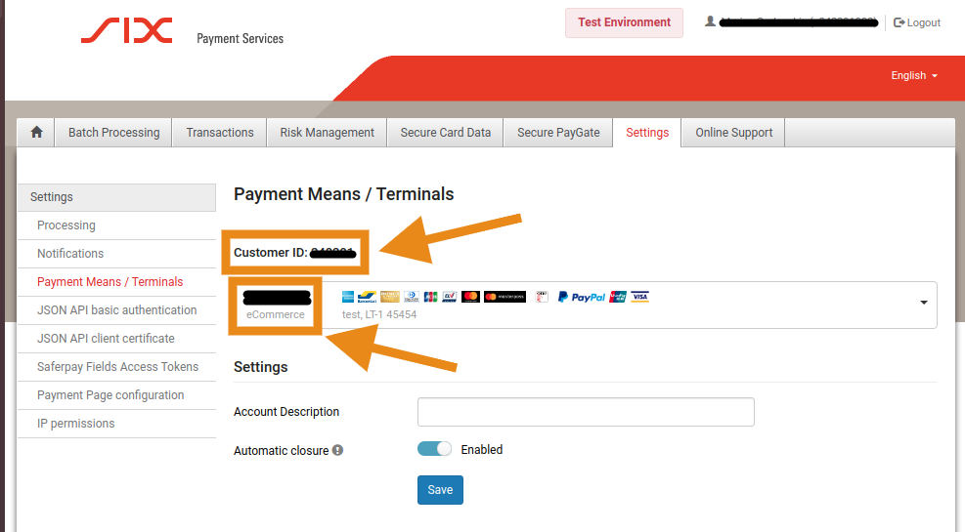

In this menu item you can see Customer ID and right below it you can see your Terminal ID.

Saferpay has two licenses:

Saferpay E-Commerce

Saferpay Business

Which one should you get? Saferpay E-Commerce covers basic needs of every merchant. Saferpay Business provides additional functionality such as: refunds via PrestaShop, order management and Secure Data Storage for the buyers.

In case you are using Saferpay Business without the corresponding license, the API will throw an error.

If you have Business license you should set “I have Business license” to YES.

## Setting

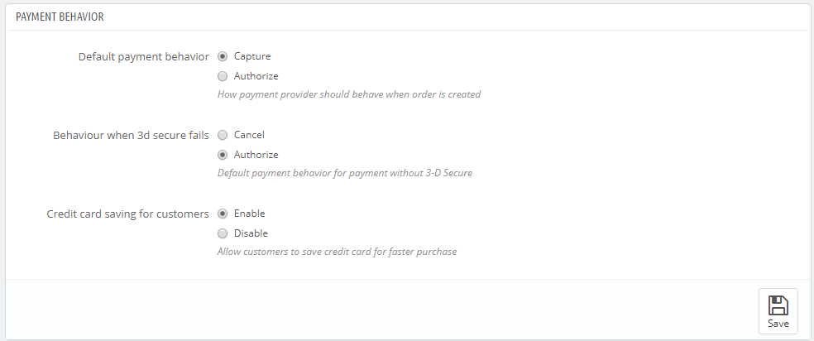

Default payment behavior – how payment provider should behave when order is created. There are two options:

Capture – automatically capture the amount in the order. Default. Keep in mind that automatic capture in some countries can be against the law.

Authorize – payment will be authorized, but merchant will have to capture manually.

Behavior when 3-D Secure fails - how payment provider should behave when payment fails to provide 3-D Secure verification. There are two options:

Cancel – payment will not be accepted. Default.

Authorize – payment will be authorized, but merchant will have to capture manually. By capturing merchant takes full responsibility on himself.

Credit card saving for customers – add options of secure data storage for faster checkout for the buyer. You can disable it if it confuses your customers.

## Styling

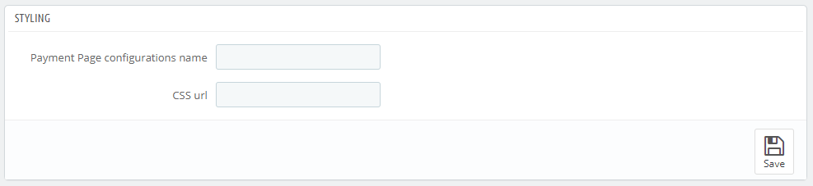

If default Saferpay look doesn’t fit your website, there are two options how you can change it.

In your Saferpay account there is a possibility to create custom design of payment page with dedicated tools. If you do that, please enter the name of custom design you have created and it will be loaded in the next checkout session.

In Saferpay Backoffice. See „Settings > Payment Page Configuration“. Note, that it has only limited styling-options, for merchants, that do not want, or cannot deal with CSS.

Another option would be to provide link to your CSS style file, which will be loaded in the next checkout session.

There are, however, some limitations. Information about CSS-Styling can be found here:

<https://saferpay.github.io/sndbx/CssiFrame.html#css-usecss>

Especially note:

<https://saferpay.github.io/sndbx/CssiFrame.html#css-info>

# Payments tab

Payments tab displays all possible payments: Alipay, American Express, Bancontact, BonusCard, Diners Club, DirectDebit, e-przelew, eps, giropay, iDEAL, Invoice, JCB, Maestro, Mastercard, myOne, PayPal, paydirekt, Postcard, Postfinance, Sofort, TWINT, UnionPay, Visa, V PAY. Not all payment will be in your contract so be careful selecting which ones to enable and which ones leave out.

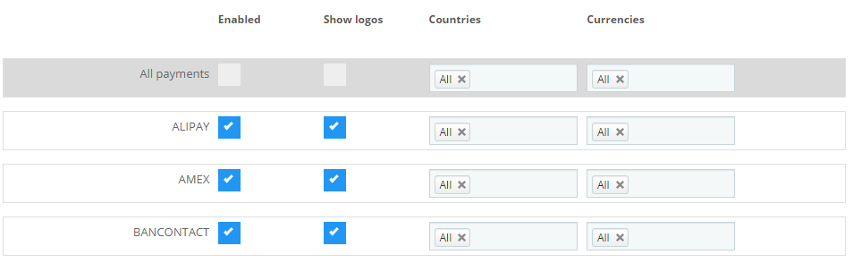

You can choose if plain text or showing payment logos suits better to your design.

Some payment methods might support only a few or one specific country, so you have to set correct countries to each payment if you don’t want your customers to be disappointed when they will not be able to accomplish payment with their desired payment option.

If you have only one currency you can set it to “All”, however if you have five or more different currencies some payments might not support all the currencies so, choose accordingly.

# Logs

The third tab in the module is Logs.

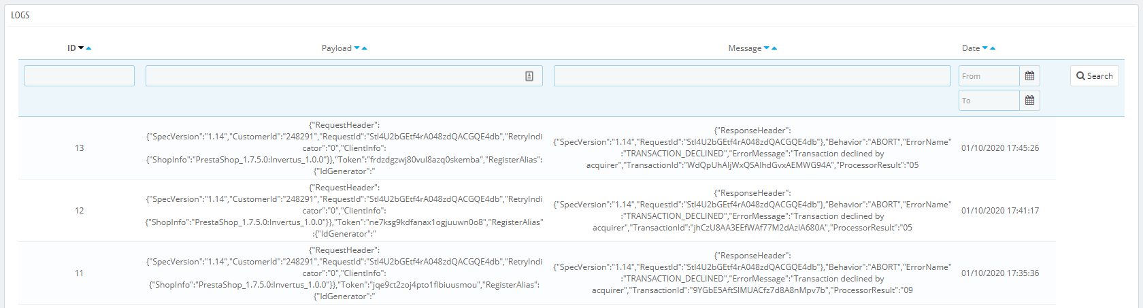

Logs contains error messages from API. If required by the Saferpay Support Team, you will have to provide the line of the log for specific incident time.

# Order management

## Orders

If you go to Orders -> Orders

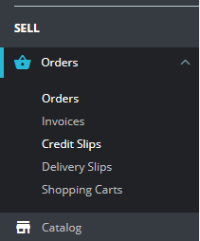

You will see a lot of orders with various statuses.

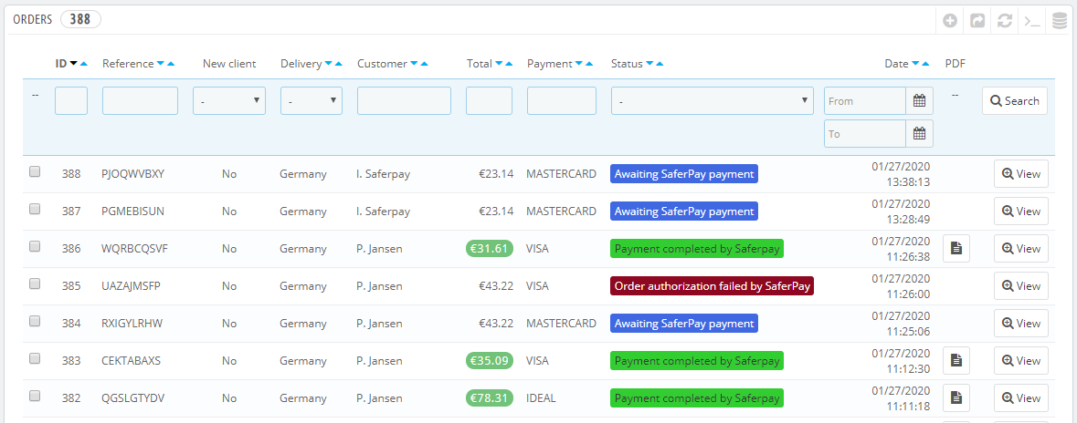

Click “View” to see more information about the order and/or perform other actions.

## Capture payment

If in the settings “Default payment behavior” is set to “Capture”, you don’t need to do anything. Payments will be captured automatically by the system.

However, if in the settings “Default payment behavior” is set to “Authorize”, you will have to capture payments manually.

In order list you will see orders with status “Payment authorized by Saferpay”, these orders will need be captured manually.

To capture the order open the order of your choice and scroll down to Saferpay block.

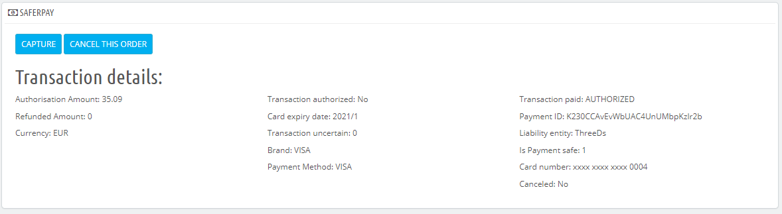

You will see to actions: “Capture” and “Cancel the order” and all information related to authorized transaction.

Click “Capture” to capture the order.

## Cancel the order

Only authorized, but not captured orders can be canceled. Captured orders can be refunded, but not canceled.

In order list you will see orders with status “Payment authorized by Saferpay”, these orders can be canceled.

To cancel the order open the order of your choice and scroll down to Saferpay block.



You will see to actions: “Capture” and “Cancel the order” and all information related to authorized transaction.

Click “Cancel the order” button to cancel the order.

## Refund payment

Only captured transactions can be refunded.

In order list you will see orders with status “Payment completed by Saferpay”, these orders can be refunded.

To refund the order open the order and scroll down to Saferpay block.

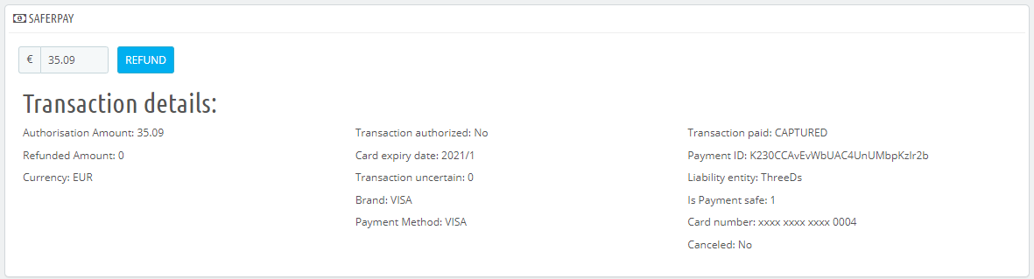

You will see input field with prefilled full amount of the order and all information related to captured transaction.

Input field allows you to perform partial refunds, just enter the amount you want to refund and click the button. If you want to do full refund, you don’t need to edit anything, just click “Refund” button. It’s not possible to refund more than the total order amount or amount lower than zero.

# E-shop customer experience

## Checkout

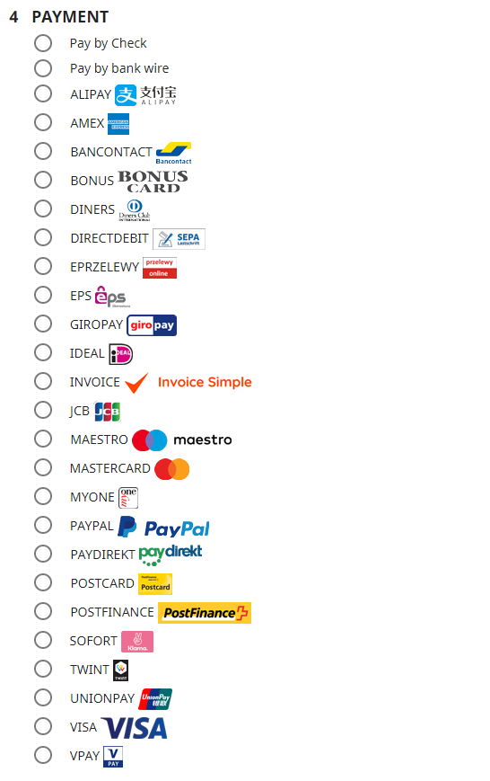In the checkout process buyer will encounter Saferpay module only in the last step.  
Buyer will see the list of all enabled payments in Saferpay as if they were independent payment providers. However, after confirmation everything will go to the same API.

If *Secure data storage* is enabled by the merchant, buyer will see additional options when selecting credit card provider like Visa.

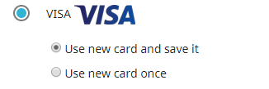

If buyer will choose first option - „*Use new card and save it*“ – his card will be saved after successful transaction. Next time buyer wants to checkout, options will be a bit different:

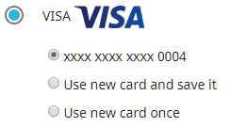

Please keep in mind that in case of unsuccessful transaction credit card will not be stored.

If merchant chooses second option – “*Use new card once*”, his credit card data will not be stored.

## Credit card management

*Please keep in mind that this option only available if Secure data storage is enabled by the merchant.*

If buyer would go to his account, he will see a button:

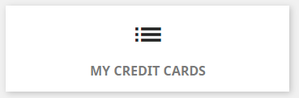

When clicked, it will display a list with all clients’ credit cards and ability to remove them.

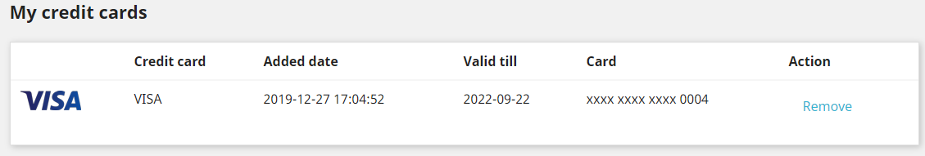

## Support Contacts

Do you have questions or a technical problem? Our specialized service teams can provide you with expert information. Here you will find the direct telephone numbers, e-mail addresses and service times for all teams: <https://www.six-payment-services.com/en/site/e-commerce-developer/logins.html>